**Scanco Catch Weight 2023.2**

Installation Guide

Scanco Catch Weight Version 7.2021

Sage 100 Version 7.20.2.1

January 2024

Contents

Introduction to Scanco Catch Weight 4

About this Guide 4

Important Information 4

Parallel Test Environment 4

Third Party Products 4

Installation Order with Scanco Multi‑Bin 4

Developer Code Change 4

Sage Production Management and Sage Operations Management 5

Required Sage 100 Modules 5

Need Assistance? 5

Scanco Catch Weight Pre-Installation Checklist 5

Scanco Catch Weight Installation Checklists 6

New Installation of Sage 100 with Scanco Catch Weight 6

New Installation of Sage 100 with Scanco Multi-Bin and Catch Weight 6

Upgrading Sage 100 with a New Installation of Scanco Catch Weight 7

Upgrading Sage 100 and Scanco Catch Weight 8

Upgrading Sage 100, Scanco Multi‑Bin, and Scanco Catch Weight 8

Upgrading Sage 100 and Scanco Multi‑Bin with a New Install of Scanco Catch Weight 9

Upgrading Sage 100 and Scanco Catch Weight with a New Install of Scanco Multi‑Bin 10

Installing Scanco Catch Weight 11

How to Install Scanco Catch Weight 11

Registering Scanco Catch Weight 15

How to Obtain Scanco Catch Weight Registration 15

How to Register Scanco Catch Weight 16

Scanco Catch Weight Hot Fixes 17

How to Install Scanco Catch Weight Hot Fixes 17

Scanco Catch Weight Developer Code Change 17

Update Custom Panels to Current Level 17

To merge custom panels: 17

# Introduction to Scanco Catch Weight

Scanco Catch Weight provides the opportunity to sell items by weight. The number of cases sold per item may be specified from Sales Order Entry. The weight for each case sold is documented when invoicing a customer’s order. Scanco Catch Weight may be used with and without Scanco Multi-Bin installed in Sage 100. Refer to the Scanco Catch Weight User Guide for more information on Scanco Catch Weight functionality.

## About this Guide

This guide provides the information necessary for installing Scanco Catch Weight.

## Important Information

Read this guide completely before installing Scanco Catch Weight version 7.2021. The Scanco Catch Weight 7.2021 installation includes Scanco Catch Weight and Sage 100 Standard, Advanced or Premium modified programs. Before installing Scanco Catch Weight 7.2021, install and register Sage 100 Standard, Sage 100 Advanced or Sage 100 Premium 2023 with Product Update 0. When Scanco Multi-Bin is to be used with Scanco Catch Weight, install Scanco Multi-Bin before installing Scanco Catch Weight.

Refer to the Sage 100 Installation and System Administrator's Guide for information on installing Sage 100 Standard, Sage 100 Advanced or Sage 100 Premium and Sage 100 2023 Product Update 0.

Please refer to the Scanco Multi‑Bin Installation guide for information on installing Scanco Multi‑Bin. Scanco Multi‑Bin must be installed before installing Scanco Catch Weight to utilized Scanco Catch Weight features.

### Parallel Test Environment

Install Scanco Catch Weight 7.2021 into a parallel test Sage 100 environment. Performing a test upgrade or a test new install allows you to resolve issues that may occur during the live upgrade or live new install, reducing downtime and allows you to get a rough estimate of how long the upgrade process will take. Refer to the [Sage Knowledgebase article ID 101266](https://support.na.sage.com/selfservice/viewdocument.do?noCount=true&externalId=101266&sliceId=1&noCount=true&isLoadPublishedVer=&docType=kc&docTypeID=DT_Article&stateId=4535&cmd=displayKC&dialogID=184412&ViewedDocsListHelper=com.kanisa.apps.common.BaseViewedDocsListHelperImpl&openedFromSearchResults=true) for more information. As not noted in the Sage Knowledgebase article before step 20, third party products must be re‑installed after a migration.

### Third Party Products

Scanco Catch Weight 7.2021 may not be compatible with non-Scanco third party products. If third-party products that integrate with your Sage product are used, check with the vendor of the third-party product to ensure that the third‑party product is fully compatible with this release. If other Sage products are integrated, check with your business partner or Sage to ensure that these components are compatible.

### Installation Order with Scanco Multi‑Bin

The order of installation for Scanco Catch Weight when Scanco Multi-Bin and Scanco Catch Weight are installed is as follows.

1. Sage 100
2. Scanco Multi-Bin
3. Scanco Catch Weight

 **Warning:** When Scanco Catch Weight exists in Sage 100 and Scanco Multi‑Bin is added to Sage 100, Scanco Catch Weight must be reinstalled after installing Scanco Multi-Bin. Refer to the Upgrading Sage 100 and Scanco Catch Weight with a New Install of Scanco Multi­‑Bin section on page 10.

### Developer Code Change

Starting with Scanco Catch Weight 7.2021, the developer code has been changed from 404 (ACS Group) to 140 (Scanco). When upgrading from 2018 or lower, a thorough review of all data is strongly advised before processing in Scanco Catch Weight 7.2021.

A purge process to remove field using the 404 developer code is currently not available in Scanco Catch Weight version 7.2021. A purge process will be available in a future release. Leaving the 404 Scanco Catch Weight fields in Sage 100 tables will not cause problems with Scanco Catch Weight functionality or data. Data values will update to the correct 140 Scanco Catch Weight fields.

C:\Users\jjackson\AppData\Local\Microsoft\Windows\Temporary Internet Files\Content.IE5\9Y4YYITQ\MC900434750[1].png **Warning**: Any custom Crystal Reports referencing 404 Scanco Catch Weight data files and/or fields must be manually updated by a Sage Partner or internal Crystal Reports specialist. A conversion utility to automate this process is not available in Scanco Catch Weight 7.2021.

### Sage Production Management and Sage Operations Management

Scanco Catch Weight does not integrate with Sage Production Management or Sage Operations Management. Scanco Multi‑Bin does integrate with Scanco Catch Weight.

### Required Sage 100 Modules

The following Sage 100 modules are required to be installed and activated to use Scanco Catch Weight.

* Library Master
* Common Information
* General Ledger
* Inventory Management
* Accounts Receivable
* Sales Order

### Need Assistance?

Please contact Scanco Support at [support@scanco.com](mailto:support@scanco.com) for assistance with Scanco Catch Weight.

# Scanco Catch Weight Pre-Installation Checklist

Complete the following pre-installation checklist prior to installing Scanco Catch Weight 7.2021 to ensure a successful installation.

* Do ***not*** install Scanco Catch Weight 7.2021 when custom modifications exist on Sage modified modules or Scanco products. Custom modifications must be retrofitted to the current Sage 100 version. Please contact your Sage partner or Scanco for information on how to obtain a quote for custom modifications to be retrofitted to Sage 100 2023 with Scanco Catch Weight 7.2021.
* Do***not*** install Scanco Catch Weight 7.2021 when extended solutions or third‑party products are installed on the Sage 100 system. Please contact your Sage partner or the Scanco Support department at [support@scanco.com](mailto:support@scanco.com) for information on evaluating extended solutions or third‑party software.
* Confirm that the Sage 100 installed version is 7.20.1.0 for the Sage 100 Standard, Sage 100 Advanced or Sage 100 Premium system. Access Help menu > About Sage to review the currently installed Sage 100 version. To review additional information on the currently installed Sage 100 system in the Sage 100 System Information window, select File menu > Run. Type *info in the Program field. Select the OK button.
* Backup the entire Sage 100 Standard, Sage 100 Advanced or Sage 100 Premium system, including programs and data files, after all data entry files are updated, and before installing Scanco Catch Weight 7.2021.
* Download the Scanco Catch Weight 7.2021 installation file and specify registration information from the Scanco Downloads page [https://scanco.com/scanco-downloads](https://scanco.com/scanco-downloads/).

**Warning:** A new registration file must be requested and activated



1. For a new installation of Scanco Catch Weight,
2. When a module or add on was recently purchased or previously not activated,
3. When the user count changes,
4. When migrating from a lower version, for example 2018.3 version 6.00.3.0 to 2023.2 version 7.00.2.0, or
5. When the subscription plan has expired or was modified.

A new registration file is not required for service releases or product updates when a registration file was previously activated. For example, a new registration file is not required when upgrading from 2023.2 version 7.00.0.0.0 to 2023.2 version 7.20.1.0 .0 and the purchased products, user count, and subscription plan have not changed.

# 

# Scanco Catch Weight Installation Checklists

## New Installation of Sage 100 with Scanco Catch Weight

* Complete the Scanco Catch Weight 7.2021 pre-installation checklist. Refer to the Scanco Catch Weight Pre-Installation Checklist on page 5.
* Install Sage 100 2023. Refer to the Sage 100 2023 Installation and System Administrator’s Guide.
* Install Product Update 0 for Sage 100 2023. Refer to the Sage 100 2023 Customer Upgrade Guide, the Sage 100 2023 Upgrade Checklist, and Sage Support for information on installing Sage Product Updates.
* Run the Sage 100 workstation setup process on all applicable workstations. Refer to the Sage 100 2023 Installation and System Administrator’s Guide.
* Install Scanco Catch Weight 7.2021. Refer to the Installing Scanco Catch Weight on page 11.
* If hot fixes are available on the Scanco Downloads page for Scanco Catch Weight version 7.2021, install Scanco Catch Weight 7.2021 hot fixes. Refer to the Scanco Catch Weight Hot Fixes section on page 17.
* Define role security for Scanco Catch Weight and Scanco Product Registration from Library Master Security menu > Role Maintenance.
* Activated Scanco Catch Weight 7.2021 from Library Master Setup menu > Scanco Product Registration. Refer to the Registering Scanco Catch Weight section on page 15.
* Activate the required and optional Sage 100 modules from Library Master Main menu > Company Information. Refer to the Sage 100 2023 Installation and System Administrator’s Guide or Sage 100 Online help.
* Create and set up company data files for required and optional Sage 100 modules. Refer to the Sage 100 2023 Installation and System Administrator’s Guide or Sage 100 Online help.

## New Installation of Sage 100 with Scanco Multi-Bin and Catch Weight

* Complete the Scanco Catch Weight 7.2021 pre-installation checklist. Refer to the Scanco Catch Weight Pre-Installation Checklist on page 5.
* Install Sage 100 2023. Refer to the Sage 100 2023 Installation and System Administrator’s Guide.
* Install Product Update 0 for Sage 100 2023. Refer to the Sage 100 2023 Customer Upgrade Guide, the Sage 100 2023 Upgrade Checklist, and Sage Support for information on installing Sage Product Updates.
* Run the Sage 100 workstation setup process on all applicable workstations. Refer to the Sage 100 2023 Installation and System Administrator’s Guide.
* Install Scanco Multi-Bin 7.2021. Refer to the Scanco Multi-Bin Installation Guide.
* If hot fixes are available on the Scanco Downloads page for Scanco Multi-Bin 2023.2 version 7.2021, download and install the hot fixes. Refer to the Scanco Multi-Bin Installation Guide.
* Install Scanco Catch Weight 7.2021. Refer to the Installing Scanco Catch Weight section on page 11.

 **Warning:** Scanco Catch Weight must be installed after installing Scanco Multi-Bin to successfully integrate the two Scanco products.

* If hot fixes are available on the Scanco Downloads page for Scanco Catch Weight version 7.2021, install Scanco Catch Weight 7.2021 hot fixes. Refer to the Scanco Catch Weight Hot Fixes section on page 17.
* Define role security for Scanco Multi-Bin, Scanco Catch Weight, and Scanco Product Registration from Library Master Security menu > Role Maintenance.
* Activate the required and optional Sage 100 modules from Library Master Main menu > Company Information. Refer to the Sage 100 2023 Installation and System Administrator’s Guide or Sage 100 Online help.
* Create and set up company data files for required and optional Sage 100 modules that integrate with Scanco Multi-Bin and Scanco Catch Weight. Refer to the Sage 100 2023 Installation and System Administrator’s Guide or Sage 100 Online help.
* Activate Scanco Multi-Bin and Scanco Catch Weight from Library Master Setup menu > Scanco Product Registration. Refer to the Registering Scanco Catch Weight section on page 15.
* Run the Sage data conversion process from Library Master Main menu > Company Maintenance. Refer to the Scanco Multi-Bin Installation Guide.
* Create Multi-Bin Data Files by selecting the Prepare button from Library Master Setup menu > Scanco Product Registration. Refer to the Scanco Multi-Bin Installation Guide.

 **Warning**: This step must be completed for all companies including companies where Scanco Multi-Bin is not activated. The Prepare Data process ensure that data dictionaries are properly merged.

* Set up Sage activated modules and Scanco Multi-Bin.

## Upgrading Sage 100 with a New Installation of Scanco Catch Weight

* Complete the Scanco Catch Weight 7.2021 pre-installation checklist. Refer to the Scanco Catch Weight Pre-Installation Checklist on page 5.
* Create a backup of the MAS90 folder. Creating a backup now will save time to revert to the folder’s original state, if needed.
* Conduct a parallel installation of Sage 100 2023 when upgrading Sage 100 from version 2020 or lower. Refer to the Sage 100 2023 Customer Upgrade Guide and the Sage 100 2023 Upgrade Checklist.
* Install Sage 100 2023 Product Update 1. Refer to the Sage 100 2023 Customer Upgrade Guide, the Sage 100 2023 Upgrade Checklist, and Sage Support for information on installing Sage Product Updates.
* Run the Sage 100 workstation setup process on all applicable workstations, when applicable. Refer to the Sage 100 2023 Installation and System Administrator’s Guide.
* Migrate and convert Sage 100 data to 2023 version 7.20.1.0 when upgrading Sage 100 from a version lower than 2023. Refer to the Sage 100 2023 Installation and System Administrator’s Guide.
* Install Scanco Catch Weight 7.2021. Refer to the Installing Scanco Catch Weight section on page 11.
* If hot fixes are available on the Scanco Downloads page for Scanco Catch Weight version 7.2021, install Scanco Catch Weight 7.2021 hot fixes. Refer to the Scanco Catch Weight Hot Fixes section on page 17.
* Back up all company data files before conducting the company conversion process.
* Define role security for Scanco Catch Weight and Scanco Product Registration from Library Master Security menu > Role Maintenance.
* Activated Scanco Catch Weight 7.2021 from Library Master Setup menu > Scanco Product Registration. Refer to the Registering Scanco Catch Weight section on page 15.
* Run the data conversion process from Library Master Main menu > Company Information.
* Activate the required and optional Sage 100 modules, if not already activated from Library Master Main menu > Company Information. Refer to the Sage 100 2023 Installation and System Administrator’s Guide or Sage 100 Online help.
* Create and set up company data files for required and optional Sage 100 modules. Refer to the Sage 100 2023 Installation and System Administrator’s Guide or Sage 100 Online help.
* Access the Custom Office Utilities menu and run the update customized panels by selecting Custom Office Utilities menu > Update Customized Panels to Current Level. Review the placement of all user-defined fields. Refer to the Sage 100 2023 Customer Upgrade Guide and the Sage 100 2023 Upgrade Checklist.
* Reset all grids.
* Review migrated data in all Sage 100 modules and companies.

## Upgrading Sage 100 and Scanco Catch Weight

* Complete the Scanco Catch Weight 7.2021 pre-installation checklist. Refer to the Scanco Catch Weight Pre-Installation Checklist on page 5.
* Create a backup of the MAS90 folder. Creating a backup now will save time to revert to the folder’s original state, if needed.
* Conduct a parallel installation of Sage 100 2023 when upgrading from version 2019 or 2020. Refer to the Sage 100 2023 Customer Upgrade Guide and the Sage 100 2023 Upgrade Checklist.
* Install Sage 100 2023 Product Update 1. Refer to the Sage 100 2023 Customer Upgrade Guide, the Sage 100 2023 Upgrade Checklist, and Sage Support for information on installing Sage Product Updates.
* Run the Sage 100 workstation setup process on all applicable workstations. Refer to the Sage 100 2023 Installation and System Administrator’s Guide.
* Install Scanco Catch Weight 7.2021. Refer to the Installing Scanco Catch Weight section on page 11.
* Migrate data following the Sage 100 parallel migration process. Refer to the Sage 100 2023 Customer Upgrade Guide and the Sage 100 2023 Upgrade Checklist.
* Reinstall Scanco Catch Weight 7.2021. Refer to the Installing Scanco Catch Weight section on page 11.
* If hot fixes are available on the Scanco Downloads page for Scanco Catch Weight version 7.2021, install Scanco Catch Weight 7.2021 hot fixes. Refer to the Scanco Catch Weight Hot Fixes section on page 17.
* Back up all company data files before proceeding to the company conversion process.
* Review role security for Scanco Catch Weight and Scanco Product Registration from Library Master Security menu > Role Maintenance.
* Activated Scanco Catch Weight 7.2021 from Library Master Setup menu > Scanco Product Registration. Refer to the Registering Scanco Catch Weight section on page 15.
* Run the data conversion process from Library Master Main menu > Company Information.
* If not previously conducted during the company conversion process from Company Information, access the Custom Office Utilities menu and run the update customized panels by selecting Custom Office Utilities menu > Update Customized Panels to Current Level. Review the placement of all user-defined fields. Refer to the Sage 100 2023 Customer Upgrade Guide and the Sage 100 2023 Upgrade Checklist.
* Reset all grids.
* Review migrated data in all Sage 100 modules.

## Upgrading Sage 100, Scanco Multi‑Bin, and Scanco Catch Weight

* Complete the Scanco Catch Weight 7.2021 pre-installation checklist. Refer to the Scanco Catch Weight Pre-Installation Checklist on page 5.
* Create a backup of the MAS90 folder. Creating a backup now will save time to revert to the folder’s original state, if needed.
* Conduct a parallel installation of Sage 100 2023 when upgrading from version 2019 or 2020. Refer to the Sage 100 2023 Customer Upgrade Guide and the Sage 100 2023 Upgrade Checklist.
* Install Sage 100 2023 Product Update 0. Refer to the Sage 100 2023 Customer Upgrade Guide, the Sage 100 2023 Upgrade Checklist, and Sage Support for information on installing Sage Product Updates.
* Run the Sage 100 workstation setup process on all applicable workstations. Refer to the Sage 100 2023 Installation and System Administrator’s Guide.
* Install Scanco Multi-Bin 2023.2 version 7.2021.
* Install Scanco Catch Weight 7.2021. Refer to the Installing Scanco Catch Weight section on page 11.
* Migrate data following the Sage 100 parallel migration process. Refer to the Sage 100 2023 Customer Upgrade Guide and the Sage 100 2023 Upgrade Checklist.
* Reinstall Scanco Multi-Bin 2023.2 version 7.2021.
* If hot fixes are available on the Scanco Multi-Bin Downloads page for Scanco Multi-Bin 2023.2 version 7.2021, download and install the hot fixes. Refer the Scanco Multi-Bin Installation Guide.
* Reinstall Scanco Catch Weight 7.2021. Refer to the Installing Scanco Catch Weight section on page 11.
* If hot fixes are available on the Scanco Downloads page for Scanco Catch Weight version 7.2021, install Scanco Catch Weight 7.2021 hot fixes. Refer to the Scanco Catch Weight Hot Fixes section on page 17.
* Back up all company data files before proceeding to the company conversion process.
* Review role security for Scanco Multi-Bin, Scanco Catch Weight, and Scanco Product Registration from Library Master Security menu > Role Maintenance.
* Activated Scanco Multi-Bin 7.2021 and Scanco Catch Weight 7.2021 from Library Master Setup menu > Scanco Product Registration. Refer to the Registering Scanco Catch Weight section on page 15.
* Run the Sage data conversion process from Library Master Main menu > Company Maintenance. Refer to the Scanco Multi-Bin Installation Guide.
* Prepare Scanco Multi-Bin data files by selecting the Prepare button from Library Master Setup menu > Scanco Product Registration. Refer to the Scanco Multi‑Bin Installation Guide.

 **Warning**: This step must be completed for all companies including companies where Scanco Multi-Bin is not activated. The Prepare Data process ensure that data dictionaries are properly merged.

* When migrating Scanco Multi-Bin from 2018 or lower, review the Scanco Multi-Bin Conversion Audit Report and run Scanco Multi‑Bin Purge Old Data process. Refer to the Scanco Multi-Bin Installation Guide.

 **Warning**: Scanco Multi‑Bin data files were restructured starting in version 2019. The Scanco Multi‑Bin Conversion creates and populates the new 140_MB data files and fields. The Old Data Purge completely removes the old 404 data files and fields. Any Scanco Multi‑Bin Custom Crystal Reports referencing 404 data files and fields must be manually updated by a Sage Partner or internal Crystal Reports specialist. A conversion utility to automate this process is not currently available. Refer to the Scanco Multi‑Bin Installation Guide.

* If not previously conducted during the company conversion process from Company Information, access the Custom Office Utilities menu and run the update customized panels by selecting Custom Office Utilities menu > Update Customized Panels to Current Level. Review the placement of all user-defined fields. Refer to the Sage 100 2023 Customer Upgrade Guide and the Sage 100 2023 Upgrade Checklist.
* Reset all grids.
* Review and confirm migrated data in all Sage 100, Scanco Multi-Bin, and Scanco Catch Weight modules.

## Upgrading Sage 100 and Scanco Multi‑Bin with a New Install of Scanco Catch Weight

* Create a backup of the MAS90 folder. Creating a backup now will save time to revert to the folder’s original state, if needed.
* Conduct a parallel installation of Sage 100 2023 when upgrading from version 2019 or 2020. Refer to the Sage 100 2023 Customer Upgrade Guide and the Sage 100 2023 Upgrade Checklist.
* Install Sage 100 2023 Product Update 0. Refer to the Sage 100 2023 Customer Upgrade Guide, the Sage 100 2023 Upgrade Checklist, and Sage Support for information on installing Sage Product Updates.
* Run the Sage 100 workstation setup process on all applicable workstations. Refer to the Sage 100 2023 Installation and System Administrator’s Guide.
* Install Scanco Multi-Bin 2023.2 version 7.2021. Refer to the Scanco Multi-Bin Installation Guide.
* Migrate Sage 100 data to Sage 100 2023 through the Sage Data Migration Utility. Refer to the Sage 100 2023 Installation and System Administrator’s Guide.
* Conduct the process for upgrading Scanco Multi-Bin. Refer to the Scanco Multi-Bin Installation Guide.
* Reinstall Scanco Multi-Bin 2023.2 version 7.2021.
* If hot fixes are available on the Scanco Multi-Bin Downloads page for Scanco Multi-Bin 2023.2 version 7.2021, download and install the hot fixes. Refer to the Scanco Multi-Bin Installation Guide.
* After the migration to 2023.2 has been completed and the migrated data has been verified according to the instructions in the Scanco Multi-Bin Installation Guide, Complete the Scanco Catch Weight 7.2021 pre‑installation checklist.
* Create a backup of the MAS90 folder. Creating a backup now will save time to revert to the folder’s original state, if needed.
* Install Scanco Catch Weight 7.2021. Refer to the Installing Scanco Catch Weight section on page 11.
* If hot fixes are available on the Scanco Downloads page for Scanco Catch Weight version 7.2021, install Scanco Catch Weight 7.2021 hot fixes. Refer to the Scanco Catch Weight Hot Fixes section on page 17.
* Define role security for Scanco Catch Weight and Scanco Product Registration from Library Master Security menu > Role Maintenance.
* Activated Scanco Catch Weight 7.2021 from Library Master Setup menu > Scanco Product Registration. Refer to the Registering Scanco Catch Weight section on page 15.
* Prepare Scanco Multi-Bin data files by selecting the Prepare button from Library Master Setup menu > Scanco Product Registration. Refer to the Scanco Multi‑Bin Installation Guide.

 **Warning**: This step must be completed for all companies including companies where Scanco Multi-Bin is not activated. The Prepare Data process ensure that data dictionaries are properly merged.

* When migrating Scanco Multi-Bin from 2018 or lower, review the Scanco Multi-Bin Conversion Audit Report and run Scanco Multi‑Bin Purge Old Data process. Refer to the Scanco Multi-Bin Installation Guide.

 **Warning**: Scanco Multi‑Bin data files were restructured starting in version 2019. The Scanco Multi‑Bin Conversion creates and populates the new 140_MB data files and fields. The Old Data Purge completely removes the old 404 data files and fields. Any Scanco Multi‑Bin Custom Crystal Reports referencing 404 data files and fields must be manually updated by a Sage Partner or internal Crystal Reports specialist. A conversion utility to automate this process is not currently available. Refer to the Scanco Multi‑Bin Installation Guide.

* If not previously conducted, activate the required and optional Sage 100 modules from Library Master Main menu > Company Information. Refer to the Sage 100 2023 Installation and System Administrator’s Guide or Sage 100 Online help.
* If not previously conducted, create and set up company data files for required and optional Sage 100 modules. Refer to the Sage 100 2023 Installation and System Administrator’s Guide or Sage 100 Online help.
* Review and confirm migrated data in all Sage 100 modules and Scanco Multi-Bin.
* Set up Scanco Catch Weight settings in Item Maintenance.

## Upgrading Sage 100 and Scanco Catch Weight with a New Install of Scanco Multi­‑Bin

Complete the Scanco Catch Weight 7.2021 pre-installation checklist. Refer to on page 5.

* Create a backup of the MAS90 folder. Creating a backup now will save time to revert to the folder’s original state, if needed.
* Conduct the upgrade process for Sage 100 and Scanco Catch Weight. Refer to the Upgrading Sage 100 and Scanco Catch Weight section on page 11.
* After Sage 100 and Scanco Catch Weight are successfully upgraded, install Scanco Multi-Bin 2023.2 version 7.2021. Follow the New Installation of Sage 100 with Scanco Multi-Bin checklist found in the Scanco Multi‑Bin Installation Guide.
* After installing Scanco Multi-Bin, reinstall Scanco Catch Weight.

**Warning:** Scanco Catch Weight must be reinstalled after adding Scanco Multi‑Bin when Scanco Catch Weight existed in Sage 100 prior to the upgrade.



* If hot fixes are available on the Scanco Downloads page for Scanco Catch Weight version 7.2021, install Scanco Catch Weight 7.2021 hot fixes. Refer to the Scanco Catch Weight Hot Fixes section on page 17.
* Define role security for Scanco Catch Weight and review existing role security settings from Library Master Security menu > Role Maintenance.
* Activated Scanco Multi-Bin and Scanco Catch Weight 7.2021 from Library Master Setup menu > Scanco Product Registration. Refer to the Registering Scanco Catch Weight section on page 15.
* If not previously conducted, activate the required and optional Sage 100 modules from Library Master Main menu > Company Information. Refer to the Sage 100 2023 Installation and System Administrator’s Guide or Sage 100 Online help.
* If not previously conducted, create, and set up company data files for required and optional Sage 100 modules. Refer to the Sage 100 2023 Installation and System Administrator’s Guide or Sage 100 Online help.
* Prepare Scanco Multi-Bin data files by selecting the Prepare button from Library Master Setup menu > Scanco Product Registration. Refer to the Scanco Multi-Bin Installation Guide.

 **Warning**: This step must be completed for all companies including companies where Scanco Multi-Bin is not activated. The Prepare Data process ensure that data dictionaries are properly merged.

* Review and confirm migrated data in all Sage 100 modules and Scanco Catch Weight.
* Set up Scanco Multi-Bin.

# Installing Scanco Catch Weight

Conduct the following steps after Sage 100 2023 with Product Update 2 is installed successfully.

## How to Install Scanco Catch Weight

1. Download the CW_2023_2_0.exe file from the Scanco Downloads page at [https://scanco.com/scanco-downloads](https://scanco.com/scanco-downloads/)
2. Right click on the Scanco Catch Weight executable file.
3. Select Run as administrator.

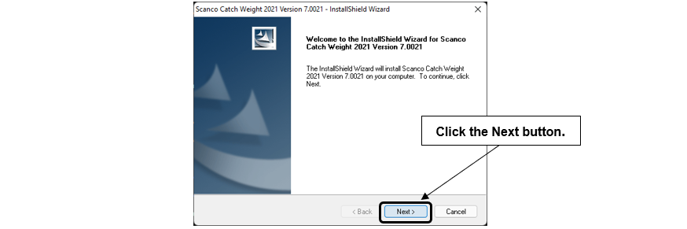

1. Select the Next button from the Scanco Catch Weight Welcome window.
2. Review the Scanco Catch Weight License Agreement.

1. Select the Yes button to agree to the Scanco Catch Weight License Agreement and to continue with the Scanco Catch Weight installation process.
2. Select the Scanco Catch Weight check boxes to install Scanco Catch Weight. Both check boxes must be selected to successfully install Scanco Catch Weight.

1. Accept the default location of Sage 100 or select the Browse button to specify the location of Sage 100.

The Choose Folder window displays after the Browse button is selected.

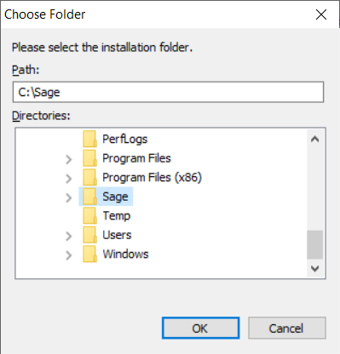

Specify the location of Sage 100 in the Path field. Select the OK button to return to the Select Features window.

1. Select the Next button from the Select Features window. The installed version of Sage 100 Standard, Sage 100 Advanced or Sage 100 Premium is validated. A warning message or the Install Scanco Catch Weight window displays.

C:\Users\jjackson\AppData\Local\Microsoft\Windows\Temporary Internet Files\Content.IE5\9Y4YYITQ\MC900434750[1].png **Warning**: Scanco Catch Weight must be installed to the same location where Sage 100 Standard, Sage 100 Advanced or Sage 100 Premium is installed. When an invalid directory location is entered in the Destination Folder field found on the Select Features window, the following message displays.

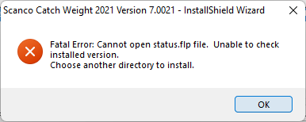

Select the OK button and modify the location where Sage 100 Standard, Sage 100 Advanced or Sage 100 Premium is installed.

C:\Users\jjackson\AppData\Local\Microsoft\Windows\Temporary Internet Files\Content.IE5\9Y4YYITQ\MC900434750[1].png **Warning**: When Sage 100 is installed but is not version 7.20.2.1, the following message displays.

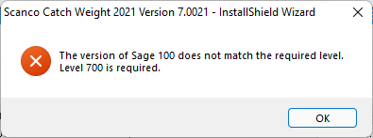

Select OK and cancel the Scanco Catch Weight installation process. Select the Cancel button from the Select Features window. The following message displays.

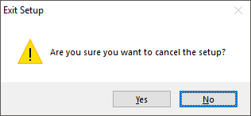

Select Yes in the message. Select the Finish button from the InstallShield Wizard Complete window to cancel the Scanco Catch Weight installation process.

**Warning**: When the Sage 100 2023 Product Update 1 has not been installed at the specified Sage 100 Standard, Sage 100 Advanced or Sage 100 Premium location, the following message displays

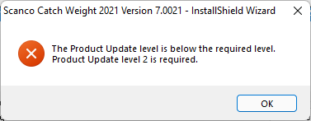

Select the OK button and then Cancel the Scanco Catch Weight installation process. Install Product Update 0 and then install Scanco Catch Weight.

C:\Users\jjackson\AppData\Local\Microsoft\Windows\Temporary Internet Files\Content.IE5\9Y4YYITQ\MC900434750[1].png **Warning**: Scanco Catch Weight may not be installed in the same location where Sage Operations Management is installed. The following message displays when the selected location contains Sage Operations Management.

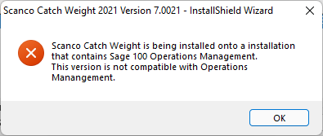

Select the OK button and then Cancel from the Select Features window.

C:\Users\jjackson\AppData\Local\Microsoft\Windows\Temporary Internet Files\Content.IE5\9Y4YYITQ\MC900434750[1].png **Warning**: Scanco Catch Weight may not be installed in the same location where Sage Production Management is installed. The following message displays when the selected location contains Sage Production Management.

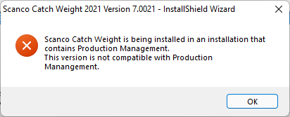

Select the OK button and then Cancel from the Select Features window.

1. Select the Install button from the following window to install Scanco Catch Weight.

1. Select the Back button to return to the Select Features window. Select the Cancel button, select Yes in the message *Are you sure you want to cancel the setup?* and the Finish button from the InstallShield Wizard Complete window to cancel the Scanco Catch Weight installation process.
2. Select the Finish button from the InstallShield Wizard Complete window to complete the Scanco Catch Weight installation process.

# Registering Scanco Catch Weight

A new registration file must be requested and activated

1. For a new installation of Scanco Catch Weight,
2. When a new module is purchased, such as Scanco Multi-Bin,
3. When the Sage 100 user count changes,
4. When migrating from a lower year version, for example 2018 version 6.00.3.0 to 2023.2 version 7.20.1.0, or
5. When the subscription plan has expired or modified.

A new registration file is not required for service releases or product updates when a registration file was previously activated at the current year version. For example, a new registration file is not required when moving from version 7.00.0.0.0 to 7.20.1.0.0.

## How to Obtain Scanco Catch Weight Registration

1. Access the Scanco Downloads page at <https://scanco.com/scanco-downloads/>.

1. Scroll down and click on Registration File Request.
2. Enter the required information in the Scanco Registration form. Fields noted with an asterisk (*) are required.
3. Select the Scanco Catch Weight check box. Select the check boxes for Scanco Multi-Bin when Scanco Multi-Bin have been purchased in addition to Scanco Catch Weight.
4. Select the Submit button.

**Note:** Please allow 1-3 business days for processing Scanco registration requests. The Scanco registration file is sent to the email specified in the Primary Contact Email field on the Registration File Request form.

## How to Register Scanco Catch Weight

1. When a license registration file is received via email, place the registration text file at …\MAS90\_Scanco in the location where Sage 100 is installed.

**Note:** Submit registration request information before downloading from the Scanco Catch Weight installer from the Scanco Downloads page and installing Scanco Catch Weight.

1. Access Library Master Setup menu > Scanco Product Registration.

1. Verify the correct Sage 100 Serial number and User Licenses displays.
2. Select the Activate button.
3. Select OK in the followingmessage.

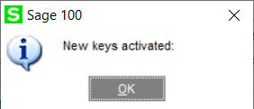

1. Verify Activated displays in the Status field for the MB-CATCH product code record.

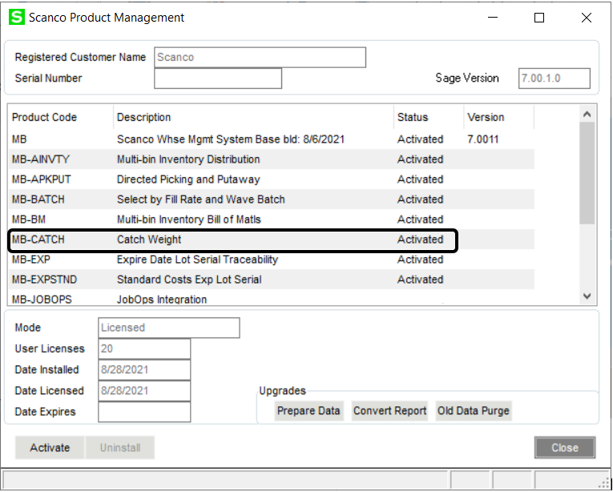

1. Select the Close button.

# Scanco Catch Weight Hot Fixes

Occasionally hot fixes are required to be installed after installing Scanco Catch Weight. Access Scanco Catch Weight hot fixes from the Scanco Downloads page <https://scanco.com/scanco-downloads/>.

## How to Install Scanco Catch Weight Hot Fixes

1. Access the Scanco Downloads page <http://info.scanco.com/scanco-downloads>
2. Click on the Scanco Catch Weight menu option.
3. Click on Hot Fixes from the Scanco Catch Weight menu.
4. Review the available hot fixes for Scanco Catch Weight for the currently installed version.

 **Warning**: Hot fixes are version and module specific. Only install hot fixes for the Scanco Catch Weight installed version.

1. Click on a hot fix link to be directed to the download file.
2. Click on the Download button.
3. Specify the location to download the hot fix.
4. Extract the hot fix file to the MAS90 directory where Sage 100 and Scanco Catch Weight are installed.

C:\Users\jjackson\AppData\Local\Microsoft\Windows\Temporary Internet Files\Content.IE5\9Y4YYITQ\MC900434750[1].png **Warning**: If the hot fix zip file is extracted to a location other than the MAS90 directory, the hot fix programs must be copied to the file location specified in the hot fix zip file.

1. Select to replace the files in the destination if the hot file was extracted to the MAS90 directory where Sage 100 and Scanco Catch Weight are installed. The hot fix program is now located in the correct directory in the Sage 100 and Scanco Catch Weight installation.
2. Review the document(s) included in the hot fix download file. Descriptions and instructions are included in this documentation.

## Scanco Catch Weight Developer Code Change

Starting with the Scanco Catch Weight 7.2021 release, the developer code has been changed from 404 (ACS Group) to 140 (Scanco). When upgrading from 2018 or lower, a thorough review of all data is strongly advised before processing in Scanco Catch Weight 7.2021.

C:\Users\jjackson\AppData\Local\Microsoft\Windows\Temporary Internet Files\Content.IE5\9Y4YYITQ\MC900434750[1].png **Warning**: Any custom Crystal Reports referencing 404 data files and fields must be manually updated by a Sage Partner or internal Crystal Reports specialist. A conversion utility to automate this process is not available from Scanco Catch Weight 7.2021.

## Update Custom Panels to Current Level

Once Scanco Catch Weight has been installed, it is prudent to merge existing screen customizations with the screen modifications that Scanco Catch Weight provides. Sage provides the Custom Office Update Custom Panels to Current Level utility to accomplish this task.

### To merge custom panels:

1. Navigate to Custom Office > Utilities > Update Custom Panels to Current Level
2. While specific Module, Task, Company, and User selections can be made, it is advised to run this utility for **all** options.

1. Select the OK button.
2. The system will display a process bar displaying the screen libraries being updated.
3. After the update is completed, if the Print Report option was selected, select to Print or Preview the Custom Office Customizer Detail Report. This is an optional step.