Issues with Allocate More than Ordered Option:
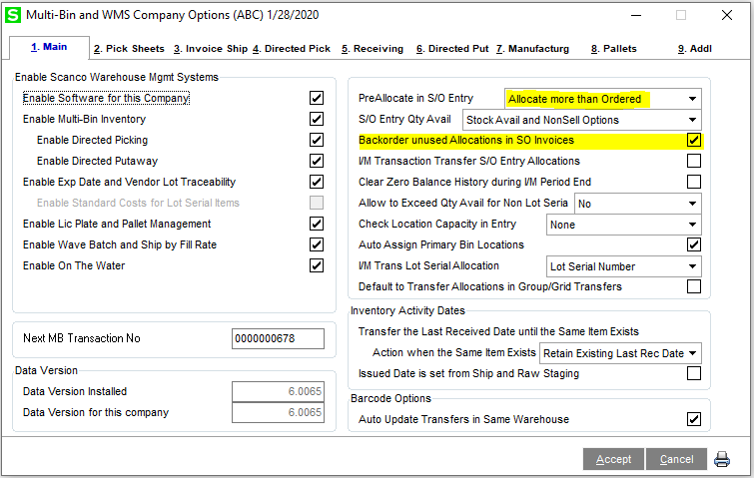

Sales Order Allows for the allocation to over distribute (correct)
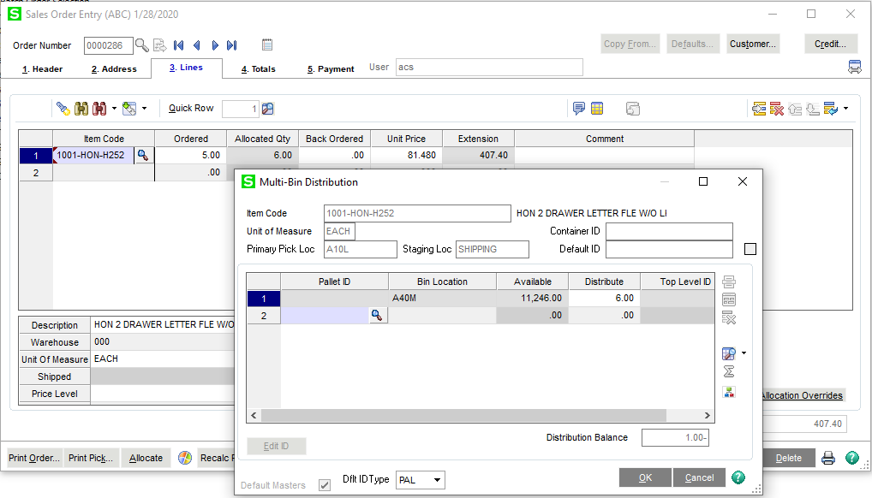
When you pull this order up in invoicing – it properly ships the 6 we selected (correct)
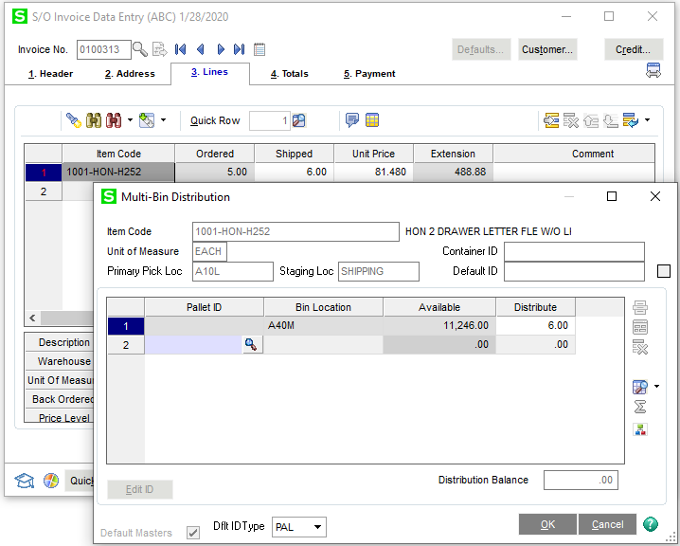
If I CANCEL this invoice, the allocation rewritten back to the order is for the ORDERED Quantity, not the original allocated quantity (INCORRECT)
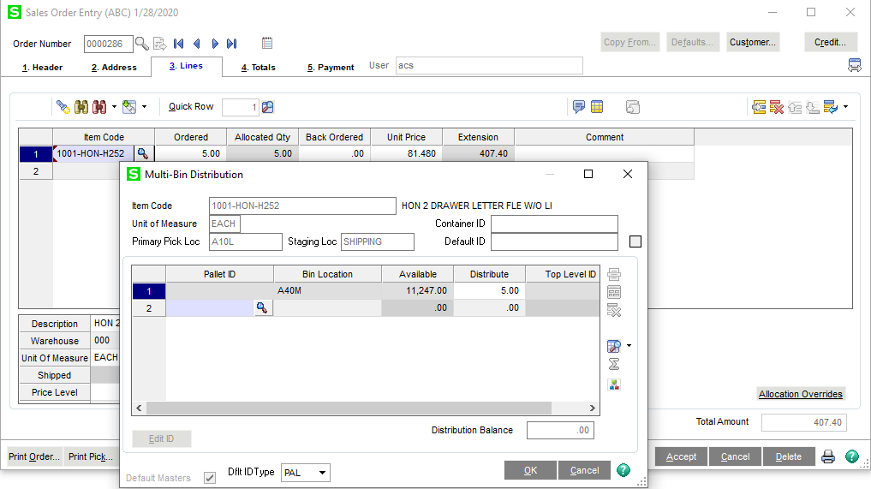
Reallocate the order for 6:
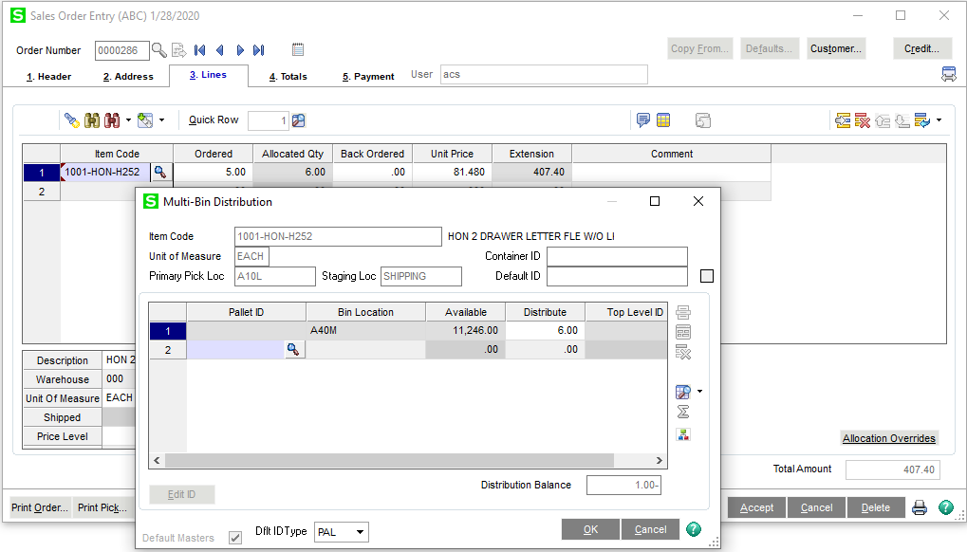
When you pull the order up in Shipping Data Entry, it back orders the ordered quantity. It does not ship the pre-allocation at all. (INCORRECT)
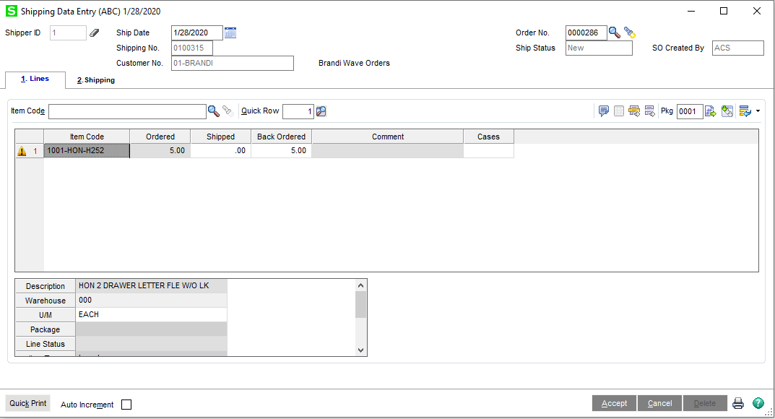
Two Additional Concerns:
- If an overallocated line is manually, legitimately backordered, will the overallocation write back to the SO Pre-Allocation properly? By the examples above, I’m guessing not, so are we allowed to over-allocate back orders with this option?
- Does this option (Allocate more than Ordered) work with saving back orders at all? I am currently unable to BackOrder more than ordered manually through SO Entry, so I’m guessing no, but I need a definitive response for the user.

