2018.6 11/19 Build (60065) + Replenishment Hot Fix
PutAway Dashboard has issues with quick transferring Serialized Items.

12 Serialized Items in the RECEIVING bin:
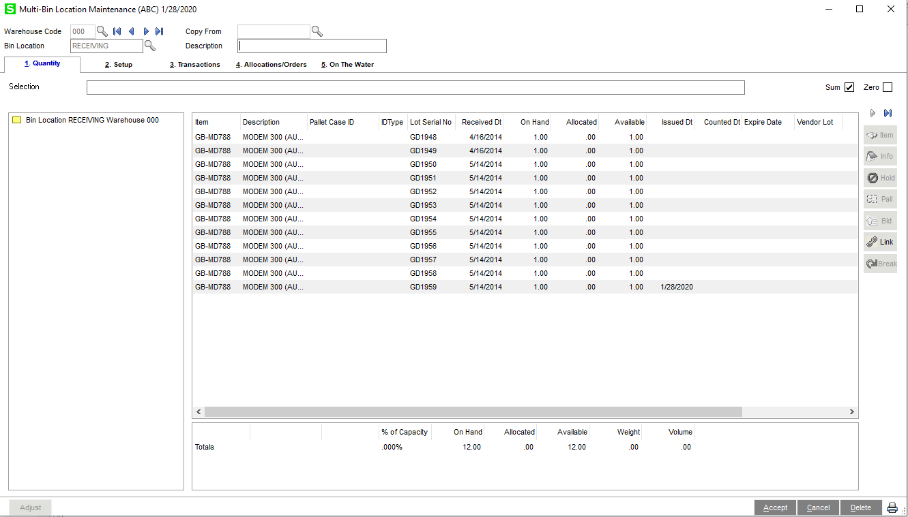
Putaway is advising C10M as the destination. On this screen, there is no indication that this item is serialized or that this line has a serial number associated with it,
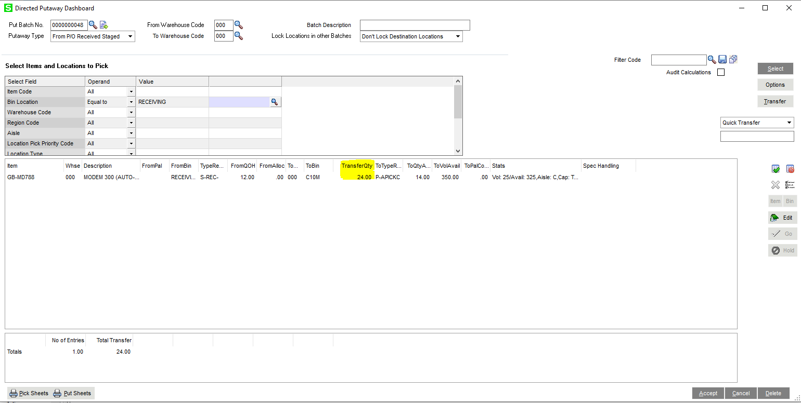
Question 1: Why is the transfer quantity 24, when there are only 12 available in the bin? I ran a recalc with all of the options selected to see if I could clear it up, but no dice.
Question 2: When I tell it to process the quick transfer, it does not take into account that this is a serialized item:
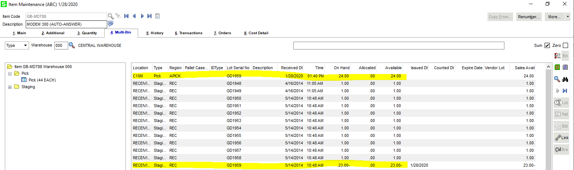
- Problem 1 – You can see that I now have an entry in C10M for 24 of the item under the GD1959 serial number. I also have an entry in RECEIVING for -23 under that same serial. Instead of creating individual transfers for each serial, it grouped them under a single serial both out of receiving and into the destination.
- Problem 2 – I’m still unsure why it was trying to transfer 24 in the first place, and it did definitely try to take them all out of RECEIVING, even though they didn’t actually exist there.

Try again with GB-MD750
Receive 5 to RECEIVING
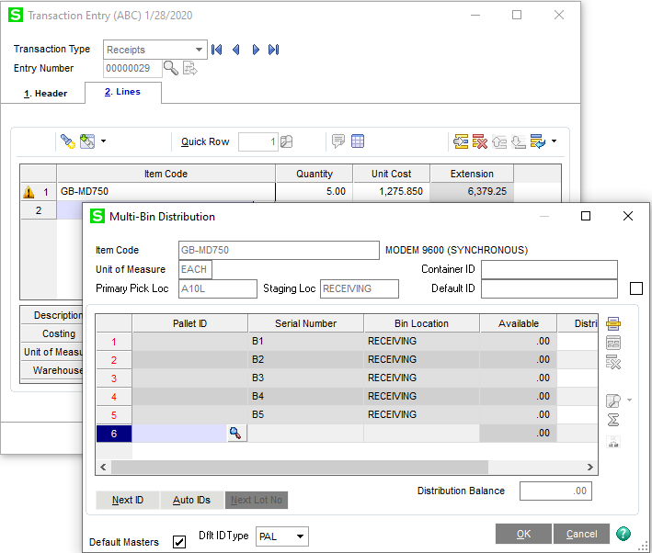
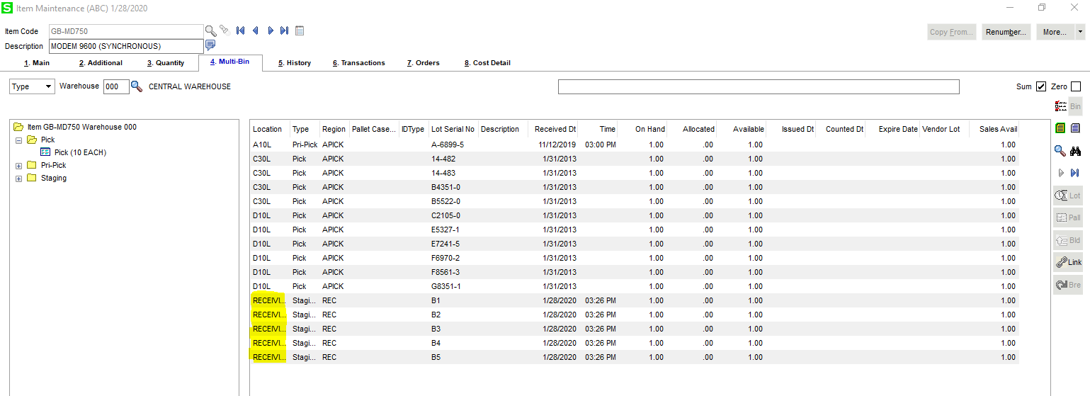
Again, the From QoH is correct, but the Transfer Quantity is doubled.
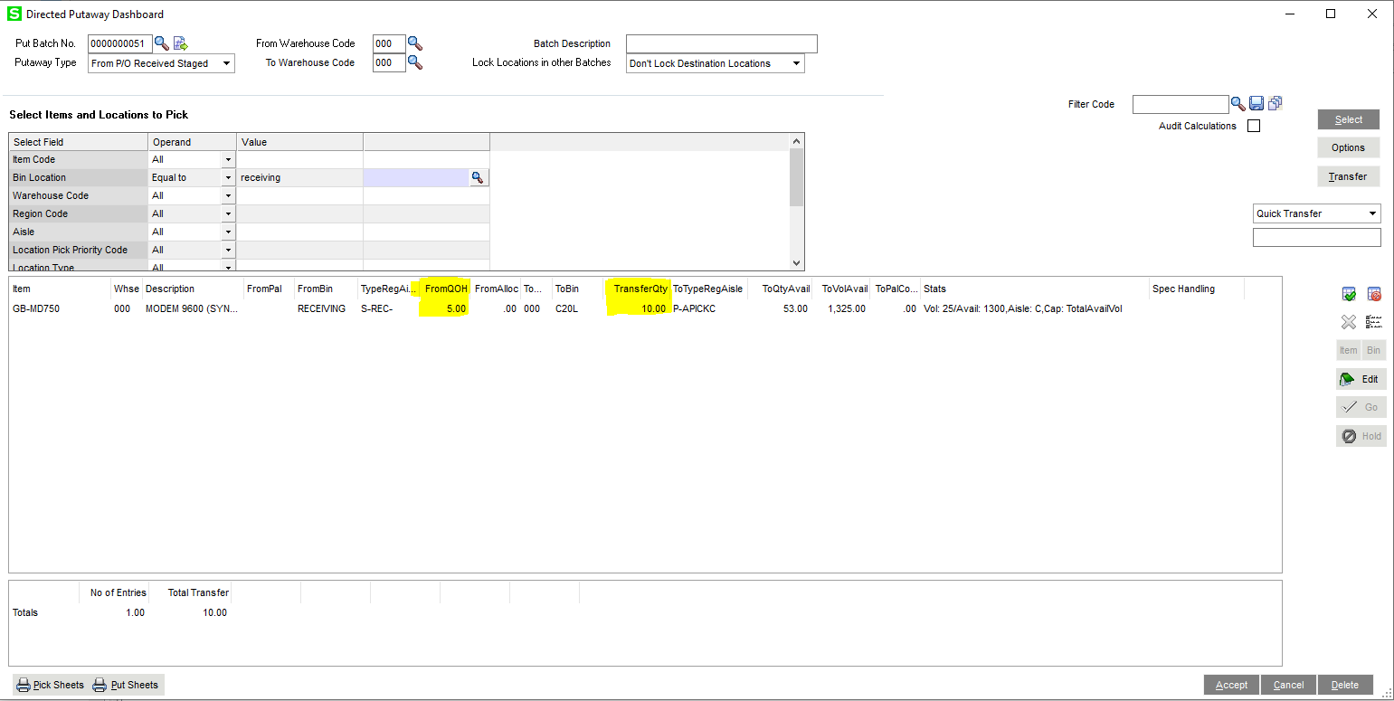
I’m also unclear on the To Qty Available listed here in the dashboard (53) and how that correlates to the actual destination bin location. ????
