2019.2 (61028) (I also duplicated this in 2018.6 – maybe this is how it is?)
User has Allocate at Order Save option set
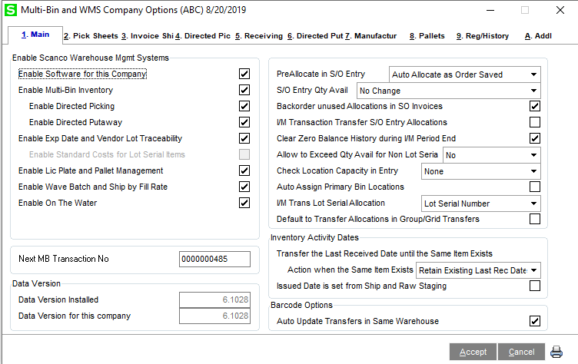
When you create an order, it allocates properly:
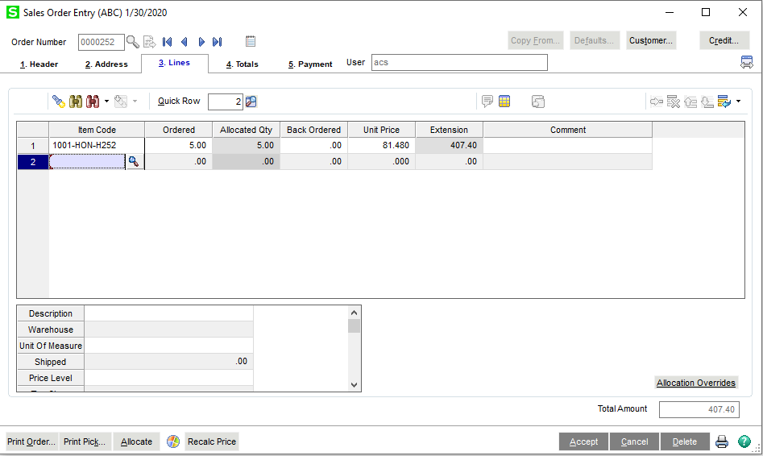

If I change the ordered amount (let’s say to 4) – I get a message that tells me it’s going to delete the distribution:
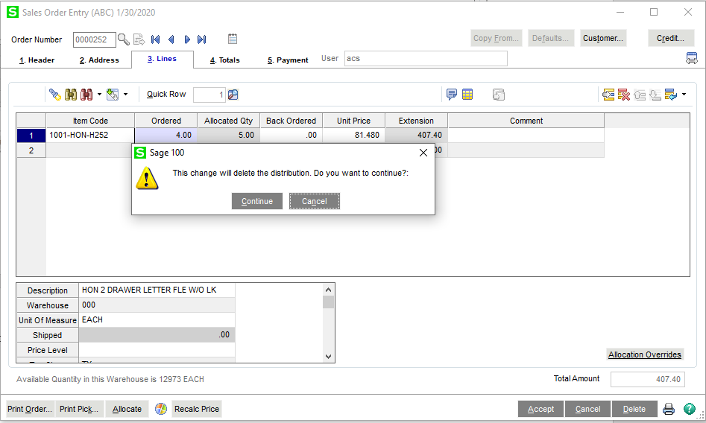
If I click continue, the distribution is deleted, and the order reallocates on save:
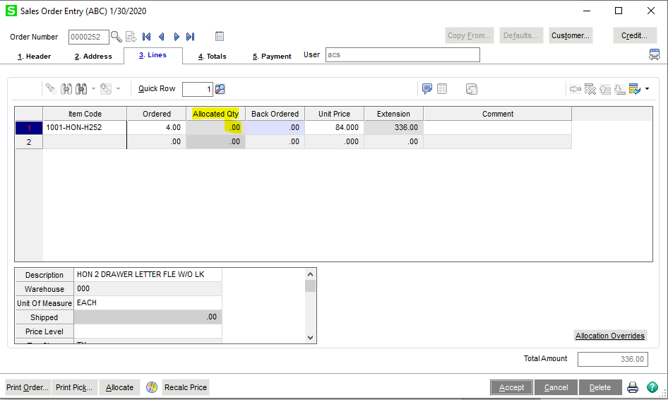
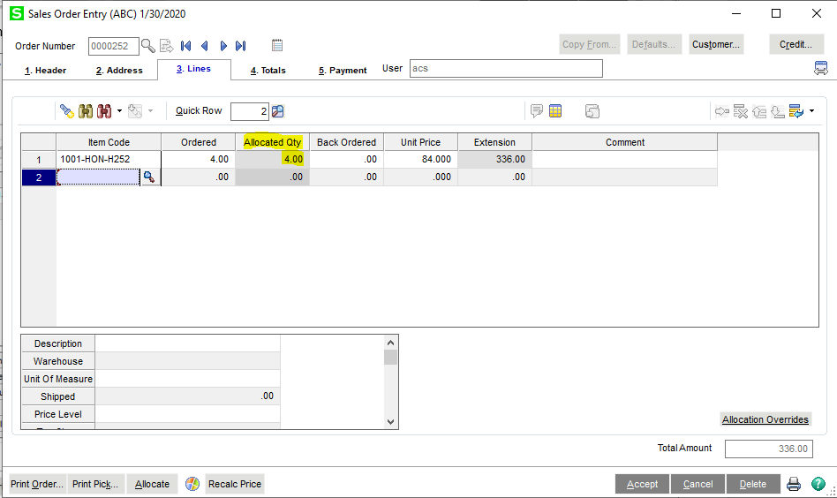
However, when changing the ordered quantity to zero (and maybe the deal here is they really should be deleting the line if they are reducing the order qty to zero?)
There’s no warning about deleting the distribution and the allocation actually stays on the line, even after save:
